EXPERIMENT – 2
BASIC IMAGE BLURRING USING GAUSSIAN BLUR
AIM
To perform basic image handling and processing operations using Python and OpenCV by reading an image and converting the image into a blurred image using Gaussian Blur.
REQUIREMENTS
Software Requirements:
• Python 3.x
• OpenCV (cv2)
• Notepad
• Command Prompt
• Windows Operating System
ALGORITHM
- Start the program.
- Import the OpenCV library.
- Read the image using cv2.imread().
- Check whether the image is successfully loaded.
- Display the original image.
- Apply Gaussian Blur using cv2.GaussianBlur().
- Display the blurred image.
- Wait for a keyboard key press.
- Close all image windows.
- Stop the program.
PROCEDURE
- Install Python on the computer.
- Install OpenCV using the command pip install opencv-python.
- Create a folder named opencv on the Desktop.
- Place the input image flower.jpg inside the opencv folder.
- Open Notepad and type the Python program.
- Save the program as image_blur.py inside the opencv folder.
- Open Command Prompt.
- Navigate to the opencv folder using the commands cd Desktop and cd opencv.
- Run the program using the command python image_blur.py.
- The original image and Gaussian blurred image will be displayed.

PROGRAM
import cv2
image = cv2.imread("flower.jpg")
if image is None:
print("Image not found")
else:
cv2.imshow("Original Image", image)
blurred_image = cv2.GaussianBlur(image, (15, 15), 0)

cv2.imshow("Gaussian Blurred Image", blurred_image)

cv2.waitKey(0)
cv2.destroyAllWindows()
COMMANDS USED
cd Desktop
cd opencv
python image_blur.py
INPUT
The input image used in this experiment is:
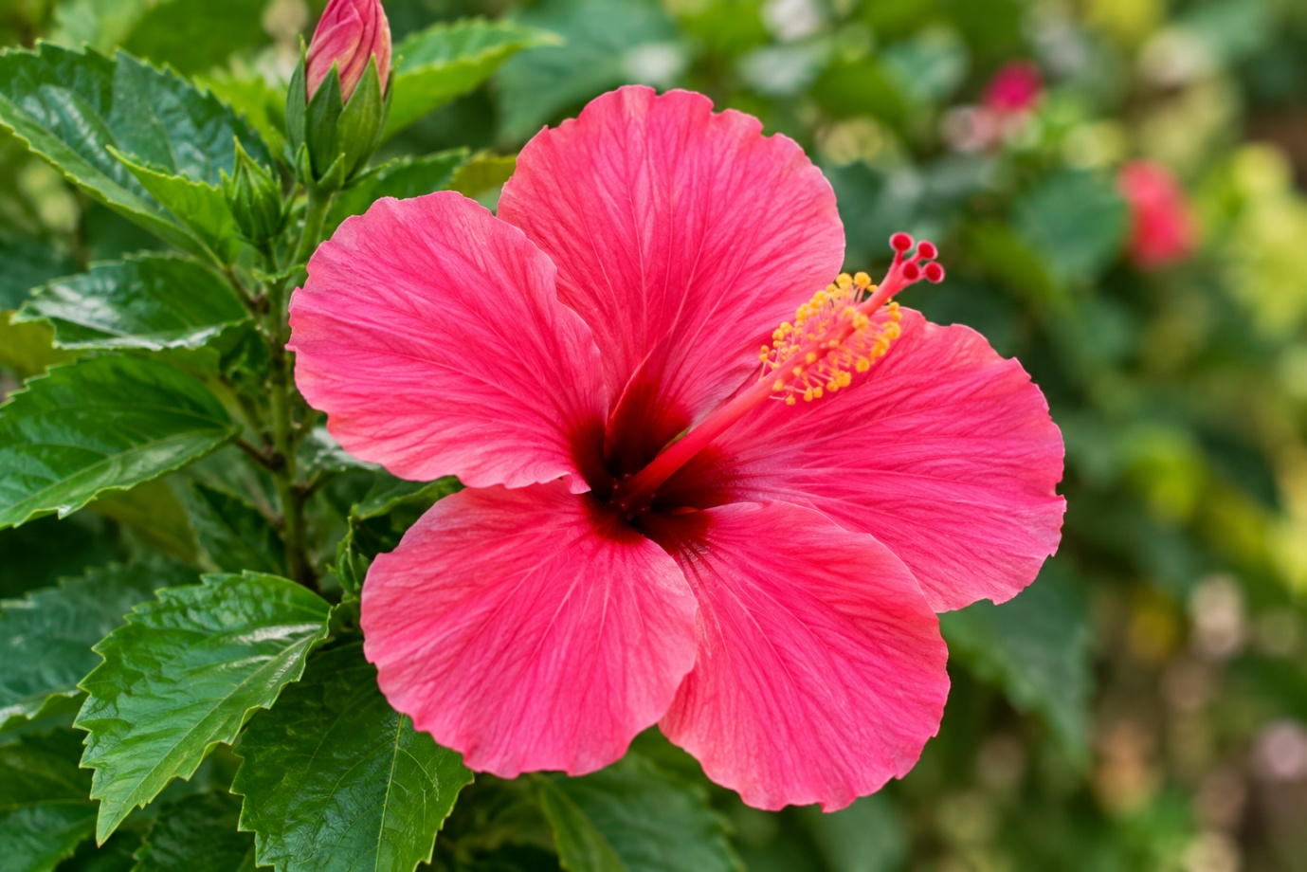flower.jpg
OUTPUT
The program displays two windows:
- Original Image
- Gaussian Blurred Image
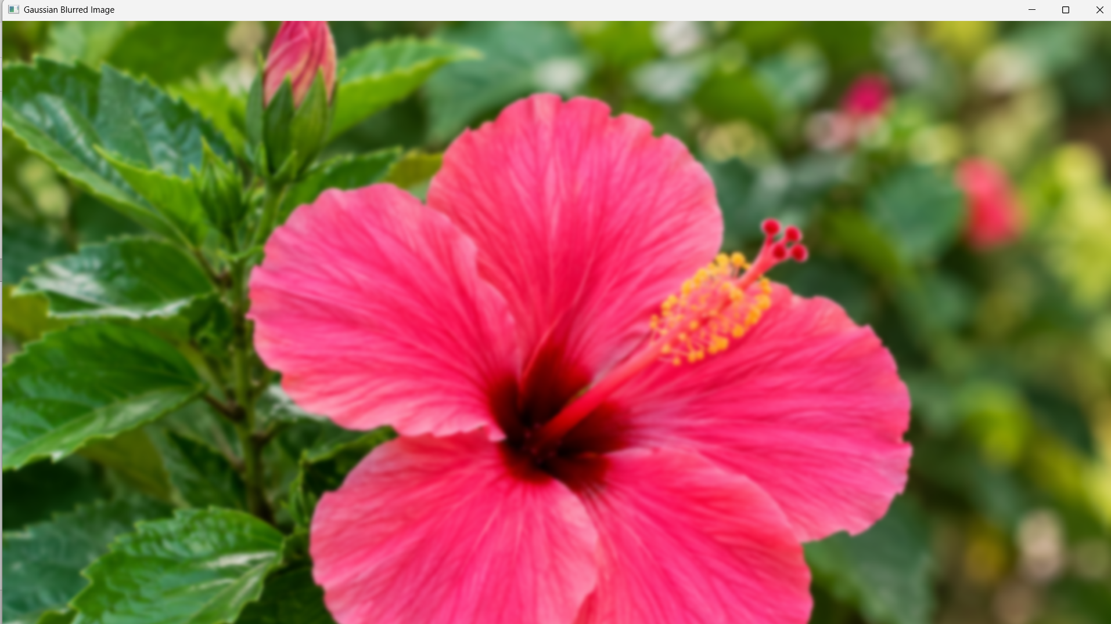
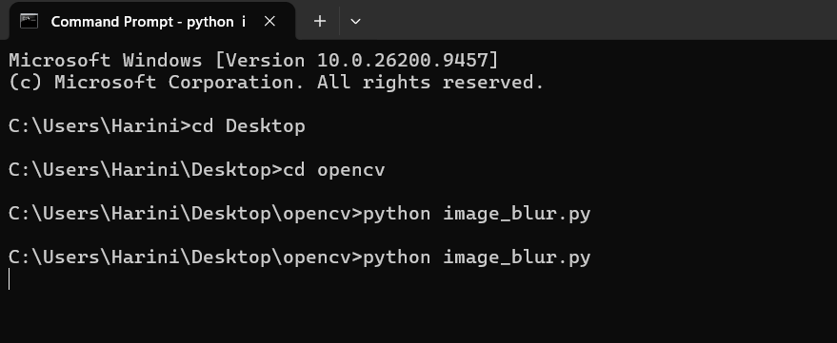

RESULT
Thus, the given image was successfully read using Python and OpenCV, and Gaussian Blur was successfully applied to produce a blurred image.

